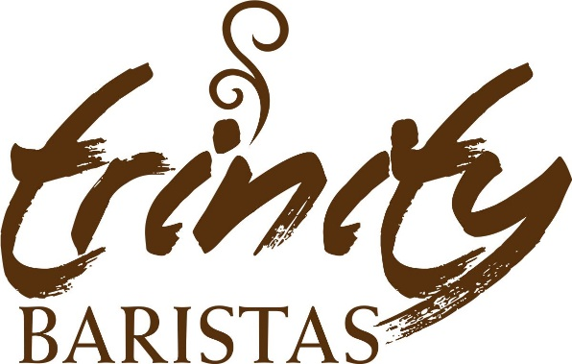

The Revolution: Full English breakfast
Two Sausages, back bacon, fried egg, two hash browns, baked beans, mushrooms, grilled tomato and toast.
£8.75
The Veggie Revolution (v)
Grilled Vegan Sausages, two fried eggs, two hash browns, baked beans, mushrooms, grilled tomato and toast.
£7.95
Chilli eggs served on a sour dough flat bread, avocado, rocket & roasted Cherry Tomatoes £7.95 (v)

Eggs Benedict served on a toasted ciabatta, a choice of ham or smoked salmon, hollandaise sauce £8.50

Breakfast Ciabatta
Breakfast Ciabatta,
Back bacon, Pork Sausage , hash browns & fried egg £4.50

Egg (V) £3.00
Vegan Sausages (V) £3.75
Bacon £3.75
Sausage £3.75
Served Daily Monday to Friday from 9.00am to 10.30am

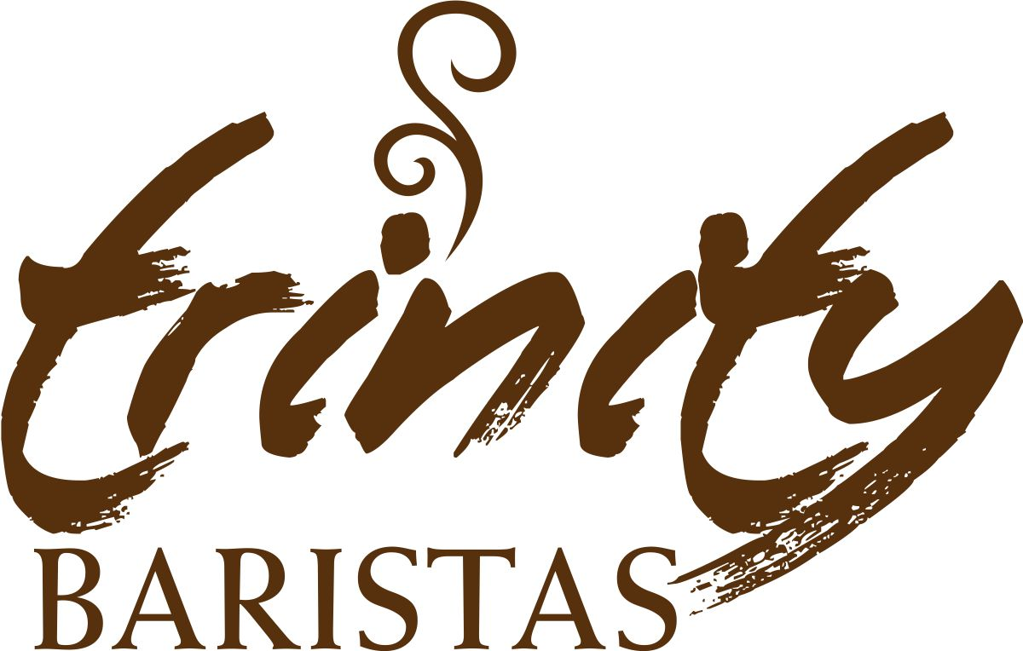

BREAKFAST IS SERVED

From
9.00am – 10.30am
Daily Monday to Friday

